**Lesson20 Azure Kubernetes Service Lab Demo**

**Notes: -**

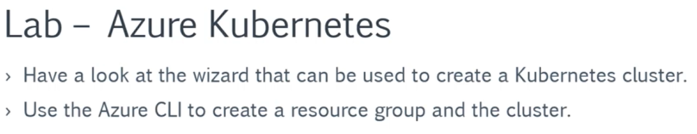

**Steps:-**

**1-in azure portal > Kubernetes service**

**(we see that we choose node size equal = 3)**

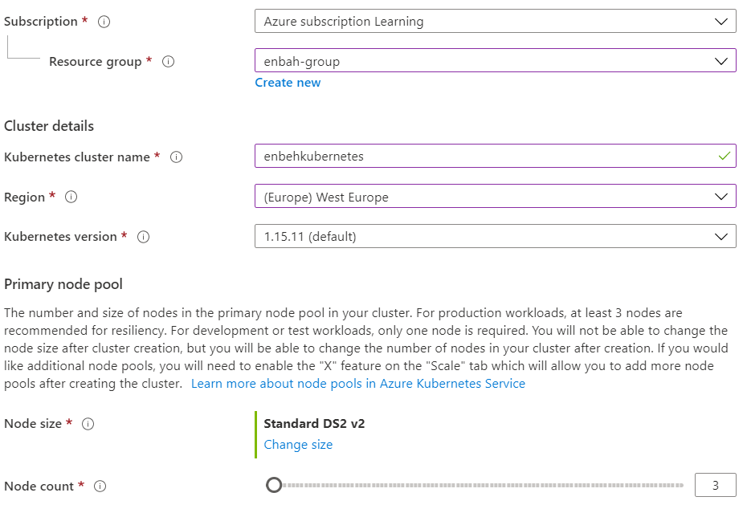

**2-on networking tab we choose Advanced option to choose the VNET**

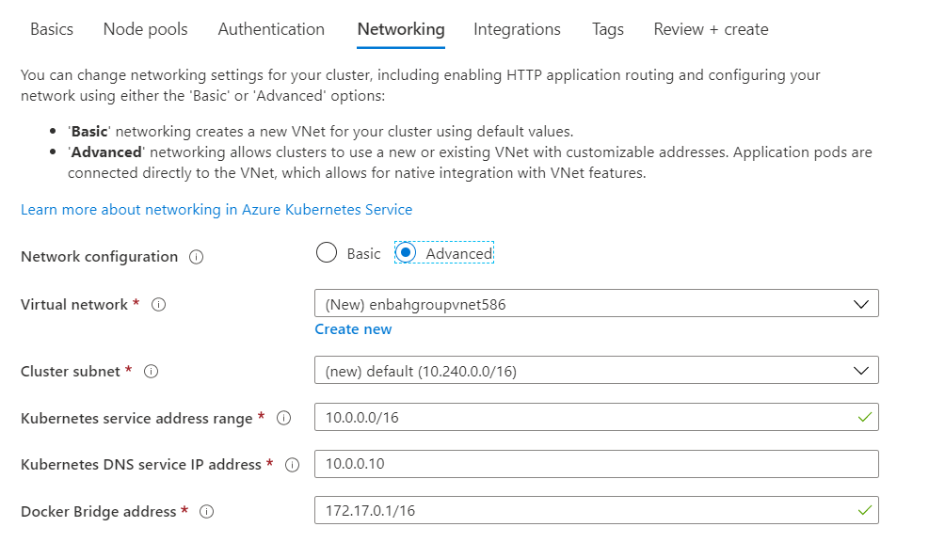

**3-in order to allow Kubernetes service to use another resources , you can use RBAC**

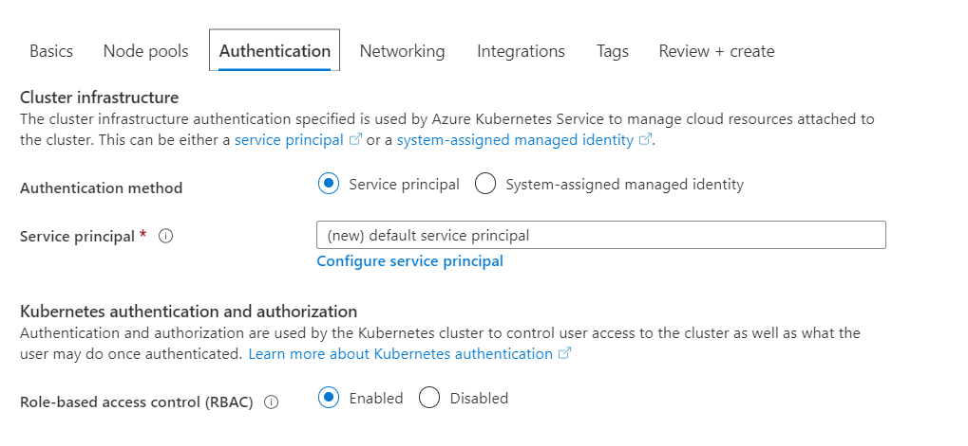

**//second way (by using Azure powershell)**

**(we will create resource group with create Kubernetes service with install kubectl that used to access to Kubernetes nodes and services)**

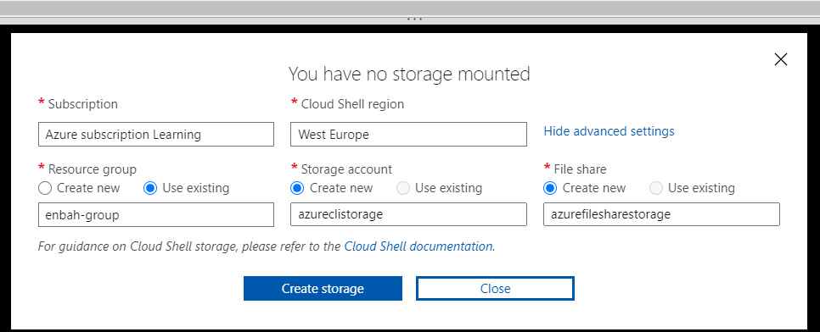

**az group create --name kubernetesgrp --location westeurope**

**(it will create resource group in west europe)**

**az aks create --resource-group kubernetesgrp --name democluster --node-count 1 --enable-addons monitoring --generate-ssh-keys**

**(it will create Kubernetes service under that resource group called democluster with 1 one and with enable monitoring with generate SSH-Key)**

**az aks install-cli --install-location=./kubectl**

**(it will install kubectl on that Kubernetes service)**

**az aks get-credentials --resource-group kubernetesgrp --name democluster**

**(to check if the credential of resource group applied to Kubernetes service)**

**KubeCtl commands**

**kubectl get nodes //to get the number of nodes running on your cluster**

**kubectl get all //to get all the services running**

**understanding of application deployment to Kubernetes cluster**

**Notes: -**

**1-Pod is the smallest part in the Kubernetes cluster service which can hold one or more containers.**

**(Cluster 🡪 multiple Nodes 🡪 each node has deployment which contains multiple Pod’s)**

**(with deployment , it can used to change the container service plus if the pod failed , it will create new pod)**

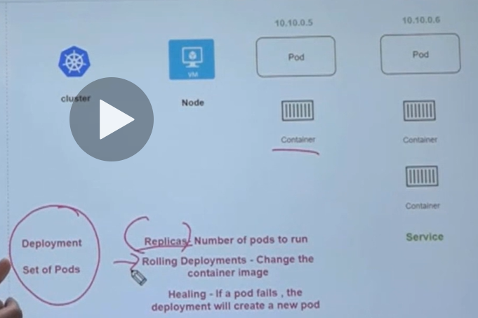

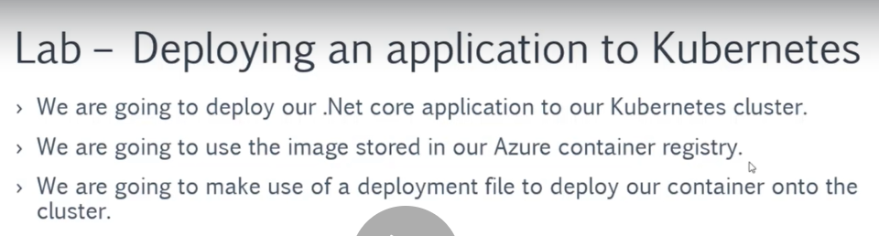

**What is the service Principal?**

**Notes:-**

**1-in order to apply the Azure Kubernetes service to get custom image from the Azure container registry, you have to get user to have permissions access of the Kubernetes service to the azure container registry**

**2-instead of this , we can use azure service principal is identity is available in azure which is separate identity that assigned with role to identity the Kubernetes service to access to azure container registry > custom docker image**

**(we see that with service principal we define ID plus assigned Role to it)**

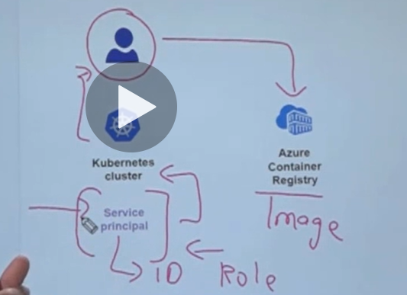

**Working with service Principal in Kubernetes cluster**

**Steps:-**

**1-make sure that the container registry service is added**

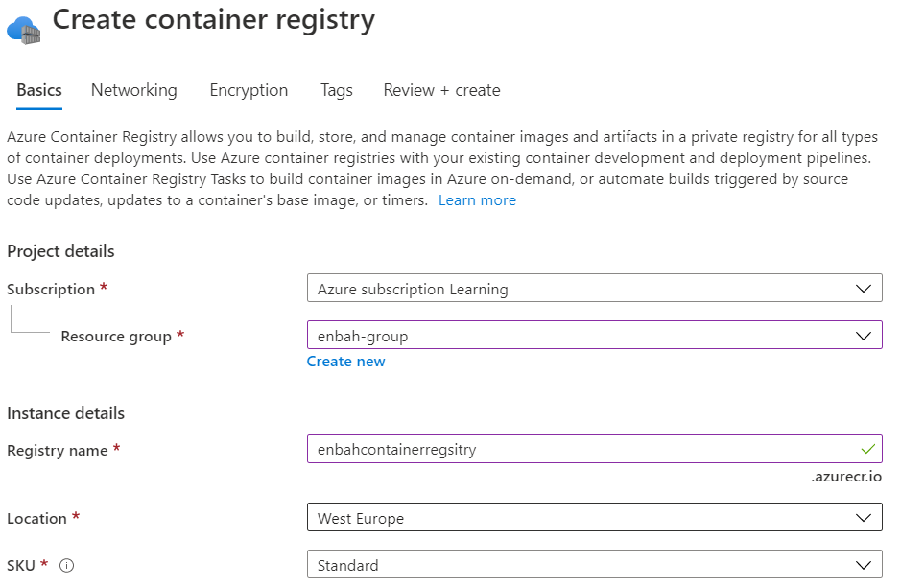

**2-we appload the 2 file app.yml and service.yml in the azure cloud shell**

**And apply the follwoign commands**

**kubectl apply -f service.yml**

**kubectl apply -f app.yml**

**kubectl get all (get the external URL and add http://20.50.150.86:5000/)**

